Discussion Questions

1)___Which of the following is considered a wilderness landscape?
a) Italian Gardens b) Central Park
c) Walden Pond d) The Rocky Mountains in the Western United States
e) all of the above
- b)
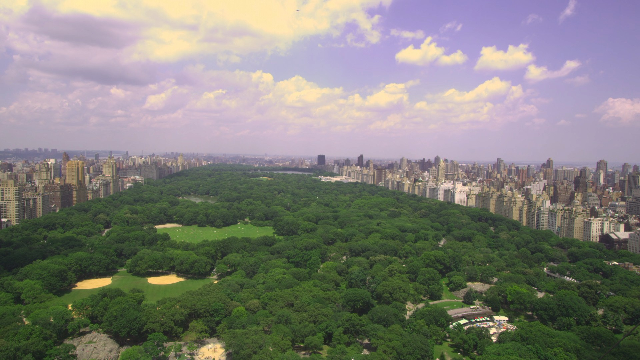
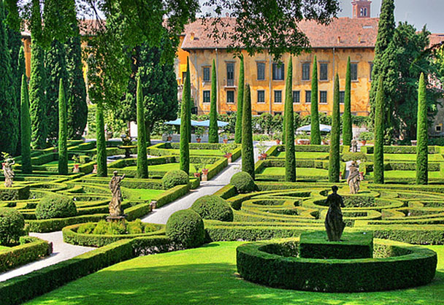

c). d)

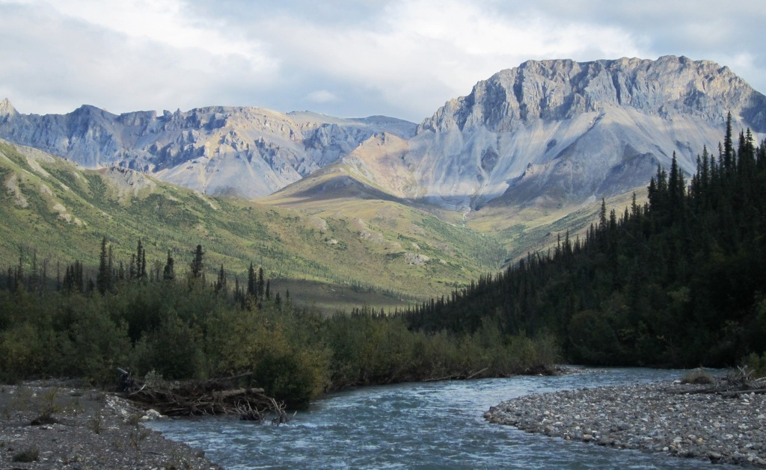
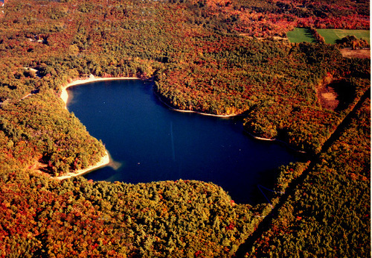

Wilderness landscape is represented by (c) walden pond; in that there are no human activities depicted from it.

2) What is the definition of nature? Do you agree with this passage: “A thing is right when it tends to preserve the integrity, stability, and beauty of the biotic community? It is wrong when it tends otherwise.” Explain if or if not Thoreau is suggesting that the integrity of the biotic community supersedes the concerns for humans? Can wilderness also include when plants take over a city that was abandoned?
Nature describes the natural, physical, material universe. I agree with the passage presented passage based on the idea that, ethics is not only considered to be philosophical and social however, it is also considered as an ecological 'procedure'. I believe that, Thoreau is proposing that the integrity of the biotic community surpasses the concerns for humans in that, people especially people involved in agriculture can produce as much as they can irrespective of ecological expenses. Moreover, wilderness cannot as well include when plants take over an abandoned city because, when people abandon the city, it is left free of human activities.
3) List one way Thoreau and Lewis and Clark differ in their viewpoints of nature and one way in which they are in common. Would they both be defenders of saving nature, would they both argue for preservation of natural landscapes? Did they study the environment and nature?
Thoreau asserts that, all people have a responsibility to respect and care for nature instead of destroying it. Lewis asserts that the law of nature is apparent since it ultimately applies to all persons. Clark believed that, people are responsible for taking care of nature. Clark, Lewis and Thoreau are common in that, they all believed that humans are charged with responsibility of caring for nature. It is important to note that Clark, Lewis and Thoreau would act as defenders of nature as they consider humans to be responsible for caring for nature; meaning that humans can defend nature by preventing the negative activities that affect nature. Thoreau, Clark and Lewis studied nature and environment.

4)What is your definition of “wilderness”? Can it be considered wilderness when plants take over a city that has been abandoned by people? Explain.
Wilderness can be defined as the natural surroundings on earth that have not been appreciably customized by human activity. It is important to note that, the term “wilderness” traditionally describes the terrestrial environments that have not been cultivated. It is important to note that, wilderness can be considered when plants take over a city abandoned by humans in that; the region is left wild and uncultivated. This is because it forms part of a garden set aside for plants growing with unchecked luxuriance.
5) Delineate between the human / nature relationships of﻿﻿﻿﻿﻿﻿ preservation, conservation and the exploitation of nature and a "do nothing" approach. Explain each perspective and link to an author. Where no author is linked to a protection of nature strategy﻿﻿﻿﻿﻿﻿﻿ just say﻿﻿﻿﻿﻿ so.﻿

Nature relationships of preservations are considered as the practices done by people to decrease ecological footprints. The exploitation of nature describes the application of natural resources for economic development, at times with a negative implication of accompanying environmental degradation. Do nothing" approach is considered as the method by which people fail to preserve nature and they take part in exploiting nature.
6) What is the difference between the terms "natural", "nature", and "wilderness."﻿﻿﻿﻿﻿﻿﻿﻿﻿﻿﻿﻿﻿﻿
The difference amid natural, nature and wilderness is based on the fact that, wilderness is considered as an unsettled and uncultivated tract of land left in its natural condition whereas nature is considered as the natural world; comprising of all things unaffected by or predating human technology, production and design for example the ecosystem. Natural is described as the virgin ground, unmodified species, laws of nature.
7) What is your definition of “wilderness”? Can it be considered wilderness when plants take over a city that has been abandoned by people? Explain.
Wilderness can be defined as the natural surroundings on earth that have not been appreciably customized by human activity. It is important to note that, the term “wilderness” traditionally describes the terrestrial environments that have not been cultivated. It is important to note that, wilderness can be considered when plants take over a city abandoned by humans in that; the region is left wild and uncultivated. This is because it forms part of a garden set aside for plants growing with unchecked luxuriance.

